**TRIGGER**

**CREATE TABLE Employee (**

**Emp_ID INT PRIMARY KEY,**

**Emp_Name VARCHAR(100),**

**Salary DECIMAL(10, 2)**

**);**

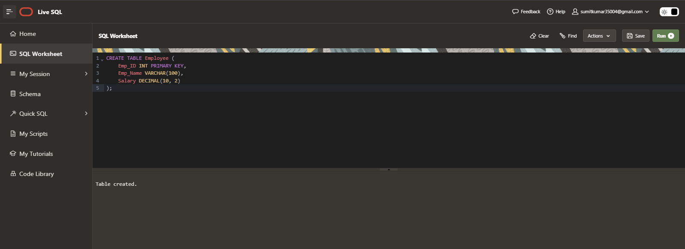

**CREATE OR REPLACE TRIGGER trg_before_insert**

**BEFORE INSERT ON Employee**

**FOR EACH ROW**

**BEGIN**

**IF:NEW.salary IS NULL THEN**

**:NEW.salary:=30000;**

**END IF;**

**END;**

**/**

**CREATE OR REPLACE TRIGGER trg_before_insert**

**BEFORE INSERT ON Employee**

**FOR EACH ROW**

**BEGIN**

**IF:NEW.salary IS NULL THEN**

**:NEW.salary:=30000;**

**END IF;**

**END;**

**/**

**INSERT INTO Employee VALUES(35 , 'smith johnson' , NULL);**

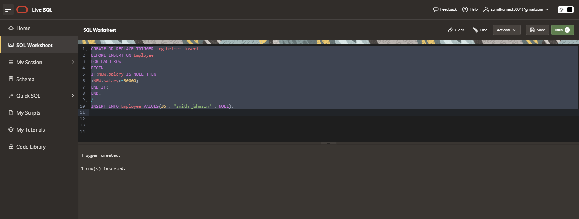

**Select * From Employee**

